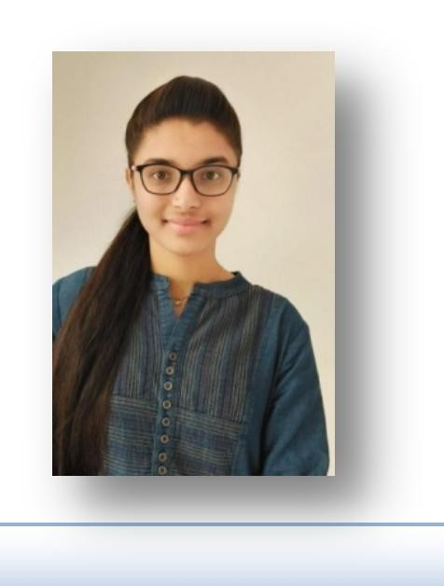

**TELANG NEHA**

**Phone no:** + 91 8766788388

**Current Address:** Hyderabad, Telangana.

**Email-Id:** [nehatelang555@gmail.com](mailto:nehatelang555@gmail.com)

**Linked-In:** [www.linkedin.com/in/neha-telang](http://www.linkedin.com/in/neha-telang)

**GitHub :**[**https://github.com/TelangNeha**](https://github.com/TelangNeha)

**Objective:**

Looking for a role that values consistent innovation and practical application of Python programming. This can help me to enhance my skills, knowledge & to contribute effectively, efficiently towards the growth of the Organization.



**Academic Education:**

|  |  |  |  |
| --- | --- | --- | --- |
| DEGREE | UNIVERSITY | PASSING YEAR | MARKS |
| BE  (MECH ENGG) | BAMU | 2021 | 80% |
| DIPLOMA | MSBTE | 2018 | 78 % |
| SSC | LATUR | 2015 | 80% |



**Technical Skills:**

* Operating System : Windows
* Application Software : Ms- Office
* Programming Languages : Programming with C, C++, JavaScript
* OOPS Language : Python 3x
* Data Base Management Systems : MySql,Sqlite3
* Web Technologies : HTML,CSS and JavaScript
* Web Frameworks : Django and Flask
* Data Science Modules : numpy, pandas, matplotlib, openpyxl etc



**Mini Project:**

* Portfolio Website |**https://telangneha.github.io/portfolio-neha/**



**Projects:**

* The Library Management System:- Used Front -end : Python, Database: MySQL , framework: Tkinter.
* Bus Reservations system:- Used Front -end : Python, Database: MySQL , framework: Django.
* Hospital management system:- Used Front -end : Python, Database: MySQL , framework: Django.



**Course and certification:**

* Certified in Course Full Stack Python Developer .
* Certified in Course SAP MM S/4 HANA .



**Personal Strength:**

* Problem solving skill, Analytical skills.
* Good communication skills.
* Highly motivated, self confident and hard working.
* Willingness to learn and time management skills.



**Personal Details:**

* Full Name : - Neha Telang.
* Father Name :- Santosh Telang.
* Date of Birth :- 26thMar. 1999
* Marital status :- Married
* Nationality :- Indian
* Language Known :- Marathi, Hindi, English
* Permanent Address :- Behind Sangamesh Theatre Gunj Area, Bhalki , Dist. Bidar, Karnataka.



**Declaration:**

I hereby declare that the above written particulars are true to the best to my knowledge and belief.

Date: Yours Faithfully,

Place: Hyderabad. TELANG NEHA